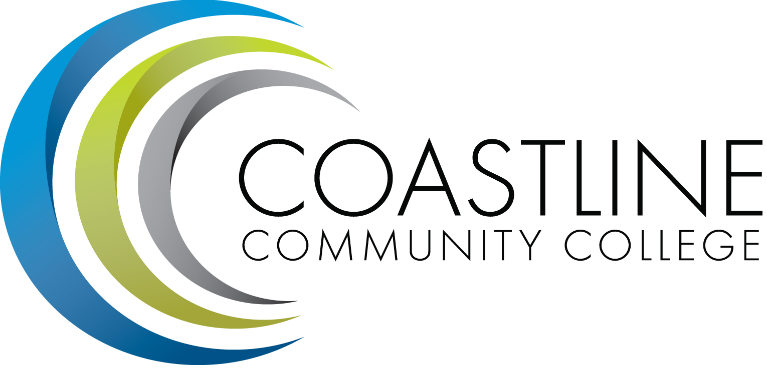
Technology Committee Agenda
02/22/2018, 3:00 p.m. – 5:00 p.m.
Annex Conference Room, Unit C

Committee Mandate: This committee is responsible for the development and evaluation of a Technology Master Plan. The committee is also responsible for:
- The development of long and short range plans and priorities for CCC to facilitate the acquisition and deployment of technology
- The review, evaluation and recommendation regarding existing and emerging technologies that will enhance student learning and improve communication and computing technologies at Coastline

- CALL TO ORDER
  - Welcome
  - Adoption of Agenda: 02/22/2018
  - Approval of Minutes: 11/16/2017
- REPORTS

- DISCUSSION
  - Technology Master Plan – Dave Thompson
  - Technology Committee Meetings – Cheryl Chapman

- ACTION ITEMS
  - Follow up on Action Items from 11/16/17:
    - Provide a full list of District IT’s definition of support software for students and staff – Dave Thompson
    - Committee members to create a list of specific questions to be sent to Dave Thompson regarding the prioritization/feasibility Assessment

- STANDING REPORTS
  - District IT Directors Meeting – Dave Thompson
  - District Technology Meeting – Dave Thompson
  - PIEAC
  - Academic Senate/FSC – Cheryl Chapman
  - Associated Student Government
  - Classified Senate
  - Canvas Work Group
- ANNOUNCEMENTS
- ADJOURNMENT
Next Meeting: March 15, 2018, 3:00-5:00 p.m., 4th Floor Conference room
*Attachment has been emailed.
**Attachment available at meeting.

